Smart Grid benchmark
What are the progress, projects and technologies of main Transmission and Distribution players?
Questionnaire v1.0 – July 2025
Dear colleague,
We intend to collect Smart Grid insights from our T&D clients’ projects and related roadmap elements.
This information will help all of us to further grow our leading position in the market.
The information will also give us important information on the key business partners, it will help us to further develop our partner strategy.
A T&D Client Partner should know the answers. We would expect it will take some 15 minutes to fill in the relevant account information.
Should you miss some info, please schedule an appointment with your client and interview him / her. 1 hour max. Deal you can make (door opener): we collect your Smart Grid roadmap high level view, we will keep it fully anonymous, and get back to you soon with a vision of the 30 largest T&D players Smart Grid vision….
As a reminder, the questionnaire is build around the Capgemini Smart Grid framework, pictured below:
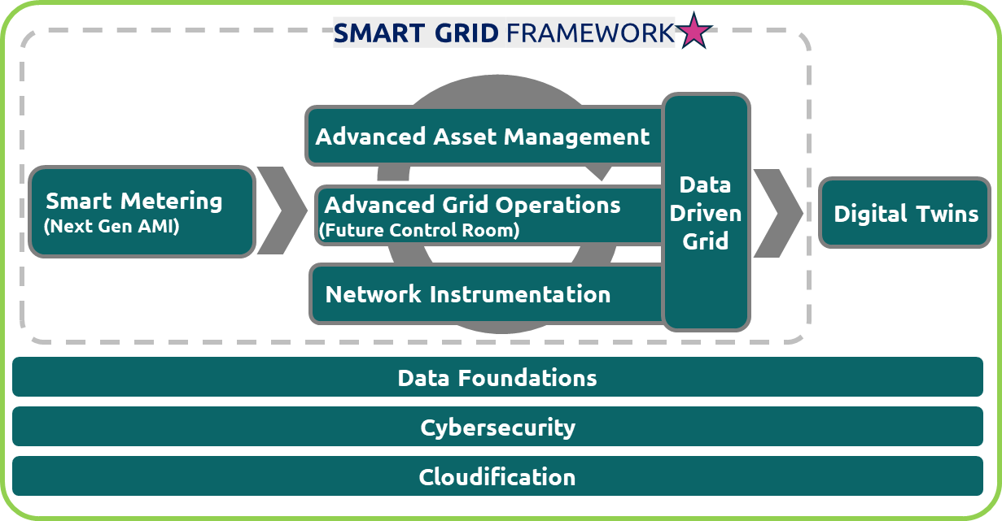

Looking forward to receiving the information!

Your contacts: Rene Kerkmeester / Philippe Vié
Company: -
Country / Region / Province: -
Who has answered: - (Capgemini Client partner (name) / Company executive name – role)
Network length: - kms
HV | MV | LV
#Delivery Points: - M
#substations: - kms
Energy delivered: - TWh pa

Smart Metering

Number of Smart Meters already deployed: -M
Year of deployment completion: -
Any large maintenance or new deployment wave forecasted? –
Technologies
Communication: PLC, RF Mesh, Point to Point, other
HES (Head-End System):
Bespoke | Package name | Supplier
Project? –
MDMS:
Bespoke | Package name | Supplier
Project? –
Are you leveraging Smart Metering data? -
If yes, use-cases? –
-

Network Instrumentation
Number of substations already equipped and %: -
Technologies (if any)
Primary substations
Bespoke | Standard | Alliance
Project? -
Secondary substations:
Bespoke | Standard | Alliance
Project? -
Priority use-cases?
–

Grid operations
SCADA / ADMS:
Bespoke | Package name | Supplier
Project? -
DERMS:
Bespoke | Package name | Supplier
Project? -
OMS:
Bespoke | Package name | Supplier
Project? -
EMS:
Bespoke | Package name | Supplier
Project? –
FLISR: (Fault Location Isolation & System Restoration)
Bespoke | Package name | Supplier
Project? -
Flexibility features:
-
Comments:
-
Control Room of the future volunteer? (Yes / No – elaborate)
Asset Management
AIP: (Asset Investment Planning)
Bespoke | Package name | Supplier
Project? -
EAM:
Bespoke | Package name | Supplier
Project? -
GIS:
Bespoke | Package name | Supplier
Project? -
Comments:
-

Data driven grid
Data platform:
Bespoke | Package name | Supplier
Project? -
Use-cases developed: (tick or put in bold the ones deployed at scale)
Feature | AI | Gen AI | Agentic AI
Feature | AI | Gen AI | Agentic AI
Feature | AI | Gen AI | Agentic AI
Feature | AI | Gen AI | Agentic AI
Feature | AI | Gen AI | Agentic AI
Feature | AI | Gen AI | Agentic AI

Project? -

Data / AI factory:
-
-
FTE? -
Project? –

Digital Twin
Platform (if any) or any Digital Twin project:
Bespoke | Package name | Supplier
Project? -
Implemented or WIP features: (tick or put in bold the ones deployed at scale)
Feature
Feature
Feature
Feature
Feature
Feature

Comments:
-

Technologies choices
OS:
Linux | Windows | Other
Project? -
Cloud:
AWS | Azure | GCP | Other
Project? –
Sovereign cloud?-
Application landscape % in the cloud: %

Comments:
-

Optional information (optional but high value)
Please describe the Smart Grid high level strategy: (priorities, next milestones, key projects, technology changes…)

Please any other relevant information…

